NOTAS PARA INTEGRATION SERVICES de SQL a SQL
Para el OLE DB Source en Data Flow, convierte el INSERT INTO en solo el SELECT:
SELECT
d.date_id,
seg.segment_id,
c.country_id,
p.product_id,
db.discount_band_id,
TRY_CAST(REPLACE(REPLACE(REPLACE(s.units_sold, '$',''),',',''),' ','') AS DECIMAL(18,2)) AS units_sold,
TRY_CAST(REPLACE(REPLACE(REPLACE(s.gross_sales, '$',''),',',''),' ','') AS DECIMAL(18,2)) AS gross_sales,
TRY_CAST(REPLACE(REPLACE(REPLACE(s.discounts, '$',''),',',''),' ','') AS DECIMAL(18,2)) AS discounts,
TRY_CAST(REPLACE(REPLACE(REPLACE(s.sales, '$',''),',',''),' ','') AS DECIMAL(18,2)) AS sales,
TRY_CAST(REPLACE(REPLACE(REPLACE(s.cogs, '$',''),',',''),' ','') AS DECIMAL(18,2)) AS cogs,
TRY_CAST(REPLACE(REPLACE(REPLACE(s.profit, '$',''),',',''),' ','') AS DECIMAL(18,2)) AS profit
FROM staging_raw s
JOIN dim_date d ON d.full_date = TRY_CAST(s.date AS DATE)
JOIN dim_segment seg ON seg.segment_name = s.segment
JOIN dim_country c ON c.country_name = s.country
JOIN dim_product p ON p.product_name = s.product
JOIN dim_discount_band db ON db.discount_band_name = ISNULL(s.discount_band, 'None');

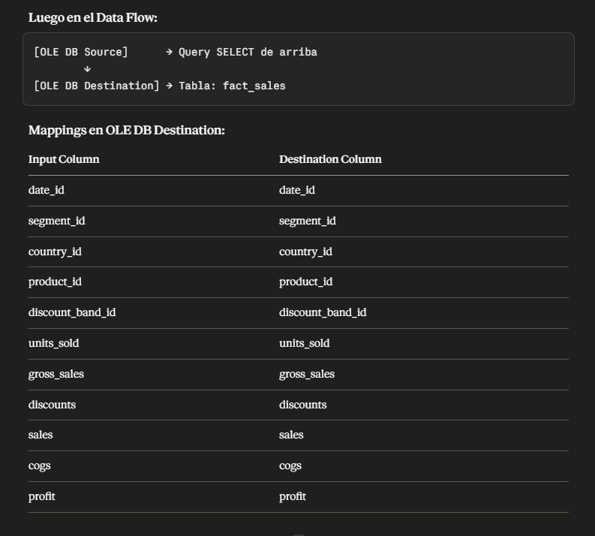

Aquí están todos convertidos a SELECT para OLE DB Source: para los DATOS DE ORIGEN
dim_segment
sql
SELECT DISTINCT segment AS segment_name
FROM [dbo].[staging_raw]
WHERE segment IS NOT NULL
AND NOT EXISTS (
SELECT 1 FROM dim_segment
WHERE segment_name = staging_raw.segment
);

dim_country
sql
SELECT DISTINCT country AS country_name
FROM [dbo].[staging_raw]
WHERE country IS NOT NULL
AND NOT EXISTS (
SELECT 1 FROM dim_country
WHERE country_name = staging_raw.country
);

dim_product
sql
SELECT DISTINCT
product AS product_name,
AVG(TRY_CAST(
REPLACE(REPLACE(REPLACE(manufacturing_price, '$',''),',',''),' ','')
AS DECIMAL(15,2))) OVER (PARTITION BY product) AS manufacturing_price,
AVG(TRY_CAST(
REPLACE(REPLACE(REPLACE(sale_price, '$',''),',',''),' ','')
AS DECIMAL(15,2))) OVER (PARTITION BY product) AS sale_price
FROM [dbo].[staging_raw]
WHERE product IS NOT NULL
AND NOT EXISTS (
SELECT 1 FROM dim_product
WHERE product_name = staging_raw.product
);

dim_discount_band
sql
SELECT DISTINCT ISNULL(discount_band, 'None') AS discount_band_name
FROM [dbo].[staging_raw]
WHERE NOT EXISTS (
SELECT 1 FROM dim_discount_band
WHERE discount_band_name = ISNULL(staging_raw.discount_band, 'None')
);
dim_date
sql
SELECT DISTINCT
date AS full_date,
month_number,
month_name,
year
FROM [dbo].[staging_raw]
WHERE date IS NOT NULL
AND NOT EXISTS (
SELECT 1 FROM dim_date
WHERE full_date = staging_raw.date
);
